Author’s Instruction for EcoDesign2015 E-book Proceedings Published from Springer
Author Name¹, Author Name²
1. Department of Design, EcoDesign University, Tokyo, Japan
E-mail: name@ecodesign.com (Please provide an email address of the corresponding author)
2. Eco Research Center, EcoDesign Co., Ltd., Tsukuba, Japan
Abstract This is an instruction for authors preparing book manuscripts for Springer. You can use this file as a template, but for more details, please see the following website, where you can download the precise template and obtain further information (http://www.springer.com/authors/book+authors). The abstract shoould be a 10-15 lines long introductory paragraph. Following the abstract, please provide 3-5 keywords.
Keywords EcoDesign, E-book paper, peer review
1. Introduction
This is an instruction for authors preparing book manuscripts for Springer. You can use this file as a template. You can find another sample for document files at: (http://resource-cms.springer.com/springer-cms/rest/v1/content/3322/data/Key+
style+points). For more details, please refer to the following website, where you can download the precise template and obtain further information (http://www.springer.
com/authors/book+authors).
2. Setting up your paper
2.1 Figure and table
Please ensure that all figure and tables are cited in the body text consecutively. Figure and tables are placed near the cited point.
2.1.1 Figure
Ensure that figures have enough resolution (over 300dpi), as they are utilized as received.
Fig. 1 is an example of a figure.

Fig. 1. Scope of EcoDesign
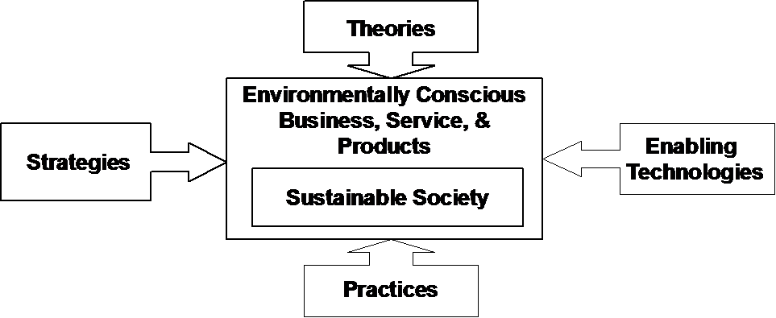
2.1.2 Table
Tables must be prepared in Microsoft Word with using Table function. This means that Excel, Power Point, PDF and image files is NOT acceptable.
Table 1. Important dates
April 30, 2015 | Abstract deadline
May 15, 2015 | Notification of acceptance
December 2-4, 2015 | EcoDesign2015 international symposium

2.2 Equation
Equations are like the following.
$a^{2}+b^{2}=c^{2}$ (1)
2.3 References and citation
Relevant works must be cited in the reference list. List the references at the end of the paper, in order of citation: [1] [2] [3].
Cite the references in the body of the paper using the number in square brackets [1]. All references listed must be cited, and all cited references must be included in the reference list.
The format for references is as follows: Last name, initial, year of publication, full paper title, journal name, volume, first and last page.
Use common abbreviations in journal names.
3. Summary
This manuscript describes the instruction for authors who publish their papers in the E-book Proceedings of EcoDesign2015.
For more details, please see the following website.
http://www.springer.com/authors/book+authors

Acknowledgments This research is supported by a Grant-in-Aid for Scientific Research.

References
- Slifka MK, Whitton JL (2000) Clinical implications of dysregulated cytokine production. J Mol Med 78:74-80
- Chung S-T, Morris RL (1978) Isolation and characterization of plasmid deoxyribonucleic acid from Streptomyces fradiae. In: Proceedings of the 3rd international symposium on the genetics of industrial microorganisms, University of Wisconsin, Madison, 4-9 June 1978
- Brown B, Aaron M (2001) The politics of nature. In: Smith J (ed) The rise of modern genomics, 3rd edn. Wiley, New York, p 234-295

